A powerful sector needs powerful data

Snapshot 1.0

Indigenous businesses provide a significant economic, social and cultural contribution to Australia. Until now, their impact has largely gone unnoticed, due to the challenge of identifying and analysing Indigenous businesses from national data sources.

The development of the Indigenous Business Longitudinal Analysis Data Environment (I-BLADE) 1.0 and the associated Snapshot 1.0 help to address this challenge. We present a unique snapshot of the Indigenous business sector (based on unprecedented data) that will challenge the many stereotypes and myths that have led to lost opportunities for Indigenous business growth.

Snapshot 1.0 is the first of our annual reports. It clearly establishes the economic power of Indigenous businesses. It will change the conversation through new insights into this powerful sector and demonstrate the need for further data development.

The challenge and the opportunity

Video

***Below are some of the facts and figures relating to registered Indigenous businesses found in I-BLADE 1.0.***

***BREADTH***

**Gross Income**

**Indigenous businesses in I-BLADE generate gross income that is four times that of non-Indigenous businesses in BLADE.** The average Indigenous business gross income is greatest in remote areas $2.1m (4.2 times as large as non-Indigenous businesses on average). This may reflect the importance of the mining and tourism industries to remote Indigenous business income.

**Figure 1: Average business gross income ($2020mill), 2017-18**

In FY2018, the last year in I-BLADE 1.0, **we observe** **3,619 active businesses, employing 45,434 people and generating total gross income of $4.9bn** (2020 terms). **This is around the same as the value of Australia’s production of vegetable crop** and more than cotton crop - $2.5bn in 2017-18 (ABS 2019). The true number is likely to be higher as not all Indigenous businesses could be linked to the BLADE.

**Business Type**

**Indigenous businesses in I-BLADE are less likely to be sole traders (9% for Indigenous businesses versus 32% for non-Indigenous companies), and more likely to be registered as companies (72% for Indigenous businesses versus 33% for non-Indigenous companies).**

**Figure 2: Types of businesses, 2017-18**

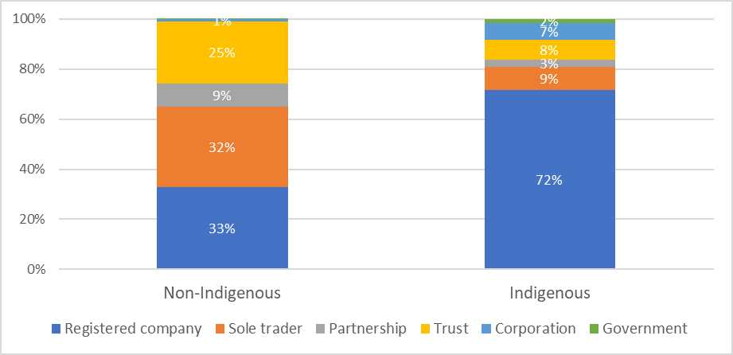

**Employment Profile**

81% of Indigenous businesses in I-BLADE employ less than 20 people, compared to 96% of non-Indigenous businesses. **On average, Indigenous businesses in I-BLADE employ 14 people compared to non-Indigenous businesses which employ 2 people**.

**Figure 3: Employment profile of Indigenous and non-Indigenous businesses, 2017-18**

**Growth in Numbers, Gross Income and Employment**

A feature of I-BLADE is the integration of historical information. This gives a sense of how the sector has evolved over time and indicates factors that may have shaped its growth now and into the future.

Our data suggests that **the numbers of active Indigenous businesses have grown at a roughly constant rate of around 4.3% per year from 2005-06 to 2017-18 or from 2,718 to 3,619.** The rate of growth in employment numbers and total Indigenous business gross income (5.9% and 6.6% per year, respectively), has been higher than the growth in number of active businesses which points to growth in the average size of active businesses, which may also point to **a maturing of the sector.**

**Figure 4: Total growth in Indigenous businesses, 2017-18**

Changes in gross income and employment over time have not followed a linear trajectory, but instead appear to have had their growth interrupted from 2014 by a reduction in mining construction expenditure. Effects are felt most strongly by, but not limited to, Indigenous businesses working in the construction sector (Figure 5). **These statistics underline the importance of the mining sector in supporting Indigenous business growth over the last 12 years**.

**Figure 5: Gross income from Indigenous-owned construction (I-BLADE) and value of mining expenditure on construction (ABS)**

**Location**

Data on the distribution of Indigenous businesses geographically is vital to understand how the new economic opportunities afforded Indigenous people from the sector’s growth are being shared.

We estimate that **58% of Indigenous businesses in I-BLADE are located outside of major cities — 32% are regional and 26% in remote locations. This compares with the non-Indigenous sector where most businesses are in major cities (74%).**

Interestingly, **Indigenous businesses in remote areas ‘punch above their weight’.** Despite only comprising 26% of all Indigenous businesses, they make-up 34% of total gross income and 37% of all employment for the sector (14,030 jobs in total).

**The greatest concentration of Indigenous businesses is in outback Western Australia and outback Northern Territory, both with more than 200 businesses in 2017-18, mainly in construction; business administration; professional, scientific, and technical services.** In terms of increase in the number of businesses, this has been highest in major cities— 8% growth per year on average compared to 2% in remote and 3.7% in regional areas.

**Figure 6: Number of Indigenous businesses by ABS Statistical Local Areas 4, 2006; 2009; 2012; 2015; 2018**



***DIVERSITY***

Diversity is an indication of the resilience of the sector in being able to weather economic crosswinds.

To measure diversity, we generate a dissimilarity index that measures how different the sectoral composition of Indigenous businesses sector in I-BLADE is from the composition of businesses in major cities, regional areas, remote areas and overall (using ABS ANZSIC Divisions).

In rural and remote areas, the composition of Indigenous businesses sector was quite different to that of non-Indigenous businesses in 2006. However, **since 2006 these indices have fallen sharply suggesting that Indigenous business growth in these areas have been associated with sectoral diversification**.

**Figure 7: Index of Indigenous businesses sectoral concentration relative to all other businesses**

Note: The dissimilarity Index measures how different the sectoral composition of Indigenous businesses are from non-Indigenous businesses. The index varies between 0 and 1, where 0 means that the sectoral composition of Indigenous businesses is exactly the same as Indigenous businesses and 1 is that they are completely different.

**Although there are Indigenous businesses represented in all nineteen ABS ANZSIC sectoral divisions in I-BLADE, there are 6 main sectors that comprise over half of all businesses in 2017-18 (Figure 8).**

**Reflecting differences in the relative size of businesses and their labour intensity, the contribution of these sectors to employment and gross earnings are quite different. Health Care and Social Assistance, despite only making up 10% of all businesses, are responsible for 24% of all employees and 19% of gross income. Construction that makes up 17% of all businesses, contributes 12% of all employment and 20% of gross income.**

**Figure 8: Composition of Indigenous businesses by ABS ANZSIC Divisions, 2017-18**

Over the period of analysis (Figure 9), the contribution of **Construction and Professional, Scientific and Technical Services and Administrative and Support Services have grown** as a share of all Indigenous businesses in I-BLADE on the back of strong average annual growth in numbers — 8%, 8.5% and 8.6% respectively. On the other hand, the contribution of **Health Care and Social Assistance businesses has shrunk**. Since 2006, the number of businesses in this sector has remained constant in remote and major cities but has declined slightly in regional areas. The composition **of Education and Training and Rental, Hiring and Real Estate Services has remained steady**, as their average annual growth rates have remained about the sector average in I-BLADE.

**Figure 9: Composition of Indigenous businesses numbers over time by ABS ANZSIC Divisions**

Note: The number of Indigenous businesses in the figure is 3,460 and not 3,619 because 159 Indigenous businesses have missing sectoral data.

***IMPACT***

**Indigenous businesses deliver a range of services to local Indigenous communities, including health and education services in a culturally sensitive manner that is essential for ensuring trust and accessibility.**

**The leading role of Indigenous health services in the response to COVID-19 in remote communities, where no loss of life was recorded**, is testament to the importance of the services that Indigenous businesses provide (Crooks et al. 2020).

**Indigenous businesses also provide cultural services to the wider community, for example through art and tourism, that help preserve and educate the wider community about the world’s oldest living culture**, enriching the lives of all Australians and building understanding, trust, and social cohesion.

**Indigenous businesses provide public benefits through employing Indigenous people.** Indigenous businesses are more likely than non-Indigenous businesses to hire Indigenous workers (Hunter 2014), which helps overcome discrimination (Shirodkar 2019, Biddle 2013).

**Increased Indigenous employment accelerates income levels and wealth generation, unlikely to occur without employment in an historically dispossessed and excluded population, and catapults individuals out of the welfare economy.**

**Improved employment and economic opportunities for Indigenous people, can also have transformative impacts on career and life aspirations** (Holzer and Neumark 2006). Especially in communities with strong businesses leaders who share their knowledge and networks, the new opportunities can transform the aspirations of an entire community.

**Development of a vibrant business sector where Indigenous people participate and interact on equal term with non-Indigenous Australians also can also help build understanding and trust** **that is vital for healing the nation.**

Measuring Impact

**The public benefits described above are difficult but not impossible to measure. In practice, we can observe community level changes in measures that approximate or act as a ‘proxy’ for a range of social and economic outcomes that coincide with growth in the Indigenous business sector across regions.**

**For example, data in Figure 10 shows Indigenous business employment numbers as a share of overall ABS SA4 business employment over time. One key observation is that in terms of local employment opportunities, Indigenous businesses in I-BLADE are consistently most important in remote areas, where Indigenous business jobs comprise more than 2% of all jobs. Further,** in 2006, Indigenous business employment as a share of total business employment only exceeded 1% in 7 ABS SA4 areas in major cities or regional areas, compared to 19 in 2018.

**Figure 10: Employment in Indigenous businesses as a share of all business employment by ABS Statistical Area Level 4, 2006; 2009; 2012; 2015; 2018**



**Jobs with** **Indigenous employers in I-BLADE 1.0 pay 3.2% more than jobs with non-Indigenous employers, including in major cities (2.7% higher), regional areas (10% higher) and remote areas (16% higher) (Figure 11).**

**Figure 11: Average annual wage paid to business employees, 2017-18**

***The Future of I-BLADE requires collective action***

These new findings underline the value of I-BLADE and the importance of further developing the data to better understand the drivers of Indigenous business growth, especially the role played by government and corporate initiatives, and quantifying the flow-on social and economic benefits to the public.

The Indigenous business sector, Indigenous business data custodians, corporates and government stakeholders can take a leading role through the following initiatives:

1. **Indigenous business data custodians** to expand coverage of registries and continue contributing annually to the development of I-BLADE
2. **Indigenous business sector leaders** to develop initiatives to grow the coverage of Indigenous owned business on these registries
3. **Individual Indigenous businesses** with an online presence that identify as Indigenous to have their ownership verified with business registration across all relevant registries to maximise their business exposure
4. **Governments** working with researchers to synchronise the collection of business statistics such as sector, business age, industry, Indigenous verification status and location that can be used to verify how different businesses that are linked to BLADE are from businesses that cannot be linked.
5. **ABS** to help develop BLADE by improving the understanding of why 40% of Indigenous businesses on registries are apparently inactive for tax purposes. Shedding light on the reasons for inactivity is important for measuring business termination/survival, a key performance measure for the sector that we hope to capture in future waves of I-BLADE.
6. **Governments and corporates** to share procurement data and employee and Indigenous community wellbeing data for the purpose of measuring impacts of IPPP and the flow-on public benefits to community and the rest of Australia.

**Together we can help shape the future of the Indigenous business sector.**

Want to know more? Please click here for the full Snapshot 1.0 report that includes in-depth explanations of our methodology, insights and more.

IMPORTANT NOTE

Source for all figures: I-BLADE 1.0, restricted to businesses that are active for tax purposes. Indigenous businesses are from Indigenous business registries (Supply Nation registry, ICN Gateway data, Victorian Aboriginal Business Directory or the ORIC database).

Note: Categories of business type are based on business registration status in the ABS Business Registry.

Partners

Partner logos here

About the authors

Associate Professor Michelle Evans

Dr Cain Polidano

Associate Professor Julie Moschion

Professor Marcia Langton

Dr Matthew Storey

Dr Victor Sojo

Professor Paul Jensen